**III)**

**Q.3.1**

Circuit Diagram:

VBE vs IB:

IB

VBE

X Axis: IB (ranging from 0 to 100µA in steps of 10µA)

Y Axis: VBE

Obtained Emitter Base Junction Voltage = 667.39572mV

VBE vs IB and VCC:

VBE

**IB**

X Axis: IB (ranging from 0 to 100µA in steps of 10µA)

Y Axis: VBE

VCC ranging from 0 to 12V in steps of 2V

The different plot lines converging together after IB shows that VBE does not depend on VCC while in Forward Active mode. The single separate plot line is for VCC = 0 , as it represents Saturation mode.

**Q.3.2**

Circuit Diagram:

IC vs VBE and Temperature:

IC

VBE

X Axis: VBE ranging from 0 to 700mV in steps of 10mV

Y Axis: IC

Calculated for temperatures 20ºC, 30ºC, 40ºC and 50ºC

This calculation shows that collector current increases with temperature during Forward Active Mode of operation

**Q.3.3**

Circuit Diagram:

Ic vs VCE and IB:

IC

VCE

X Axis: VCE (ranging from 0 to 12V in steps of 0.01V)

Y Axis: IC

IB ranging from 0 to 100µA in steps of 10µA

The boundary between the Saturation region and Forward Active region is roughly at VCE = 303.79747mV, as shown by the cursor in the plot.

Ic vs IB at VCE = 100mV (Saturation):

IB

IC

IC at IB = 50µA: 5.34046 mA

IC at IB = 60µA: 6.21322 mA

$$β=\frac{ΔI_{C}}{ΔI_{B}} = 87.276$$

Ic vs IB at VCE = 600mV (Forward Active):

IB

IC

IC at IB = 50µA: 12.9573 mA

IC at IB = 60µA: 15.2992 mA

$$β=\frac{ΔI_{C}}{ΔI_{B}} = 234.19$$

Clearly, β during Forward Active is much higher than during Saturation. This is because the collector current decreases a lot in Saturation mode, due to the Collector Base Junction being in forward bias conducting in the opposite direction.

Ic vs IB at VCE = 1V:

IB

IC

|  |  |  |
| --- | --- | --- |
| IB (uA) | IC(mA) | β |
| 10 | 2.80528 | 280.528 |
| 20 | 5.5026 | 275.13 |
| 30 | 8.10143 | 270.0477 |
| 40 | 10.6117 | 265.2925 |
| 50 | 13.0418 | 260.836 |
| 60 | 15.3989 | 256.6483 |
| 70 | 17.6893 | 252.7043 |
| 80 | 19.9181 | 248.9763 |
| 90 | 22.0902 | 245.4467 |
| 100 | 24.2097 | 242.097 |

We see a gradual decrease in the value of β, with increasing IC. This shows the presence of Early effect, since an increase in IB will cause the base width to decrease, (due to increase in VB), which leads to an increase in IC, with respect to the expected value, i.e., Early effect.

To find Early voltage, we need the plot of IC vs VCE at constant VBE,

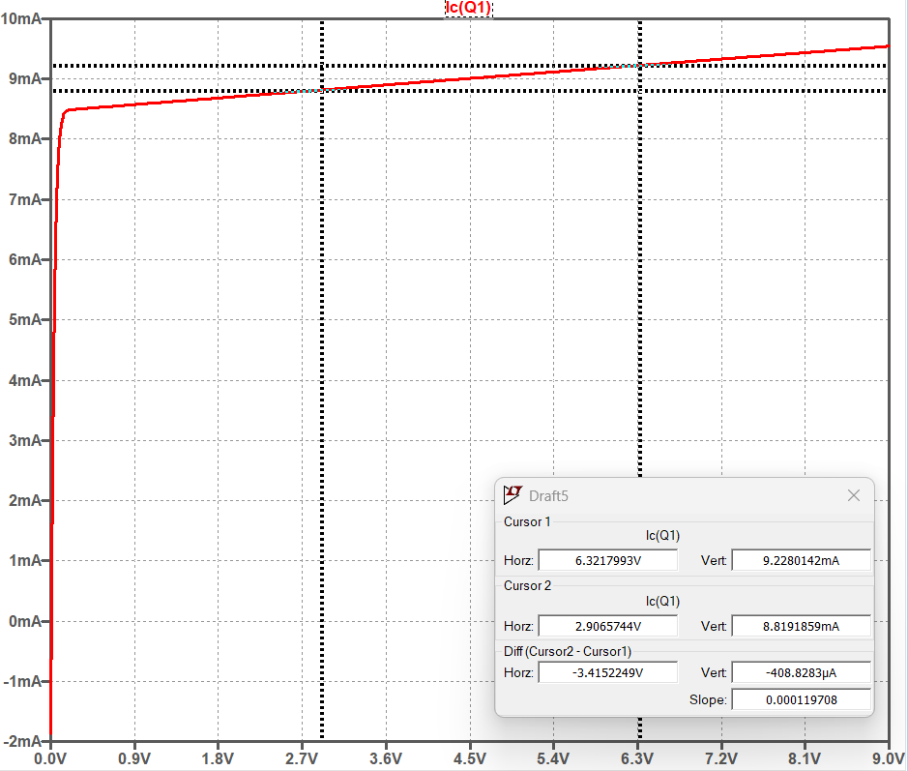

VCE

IC

Slope of the Graph = 0.000119708 A/V,

Take VCE as the average of the 2 points measured, i.e., 4.6141867 V.

IC at the edge of Forward Active Mode = 8.442923mA

We know that,

$$Slope=\frac{I_{C}}{V_{A}+V_{CE}}$$

$$⇒ V_{A}=\frac{I_{C}}{Slope}-V_{CE}$$

$$⇒V_{A}=65.91512 V$$

Therefore, the Early voltage is estimated to be 65.91512 V.